**Implementation of Selenium with JMeterController**

1. **Set up JMeter and Create a test plan**

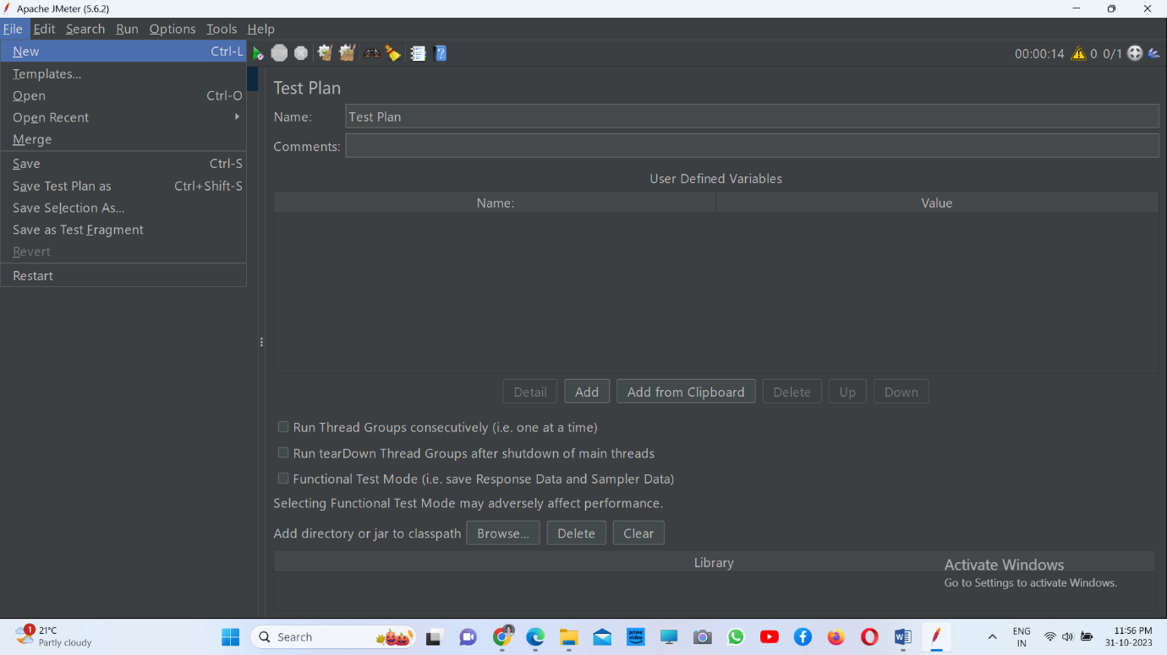

1. **Add thread group**

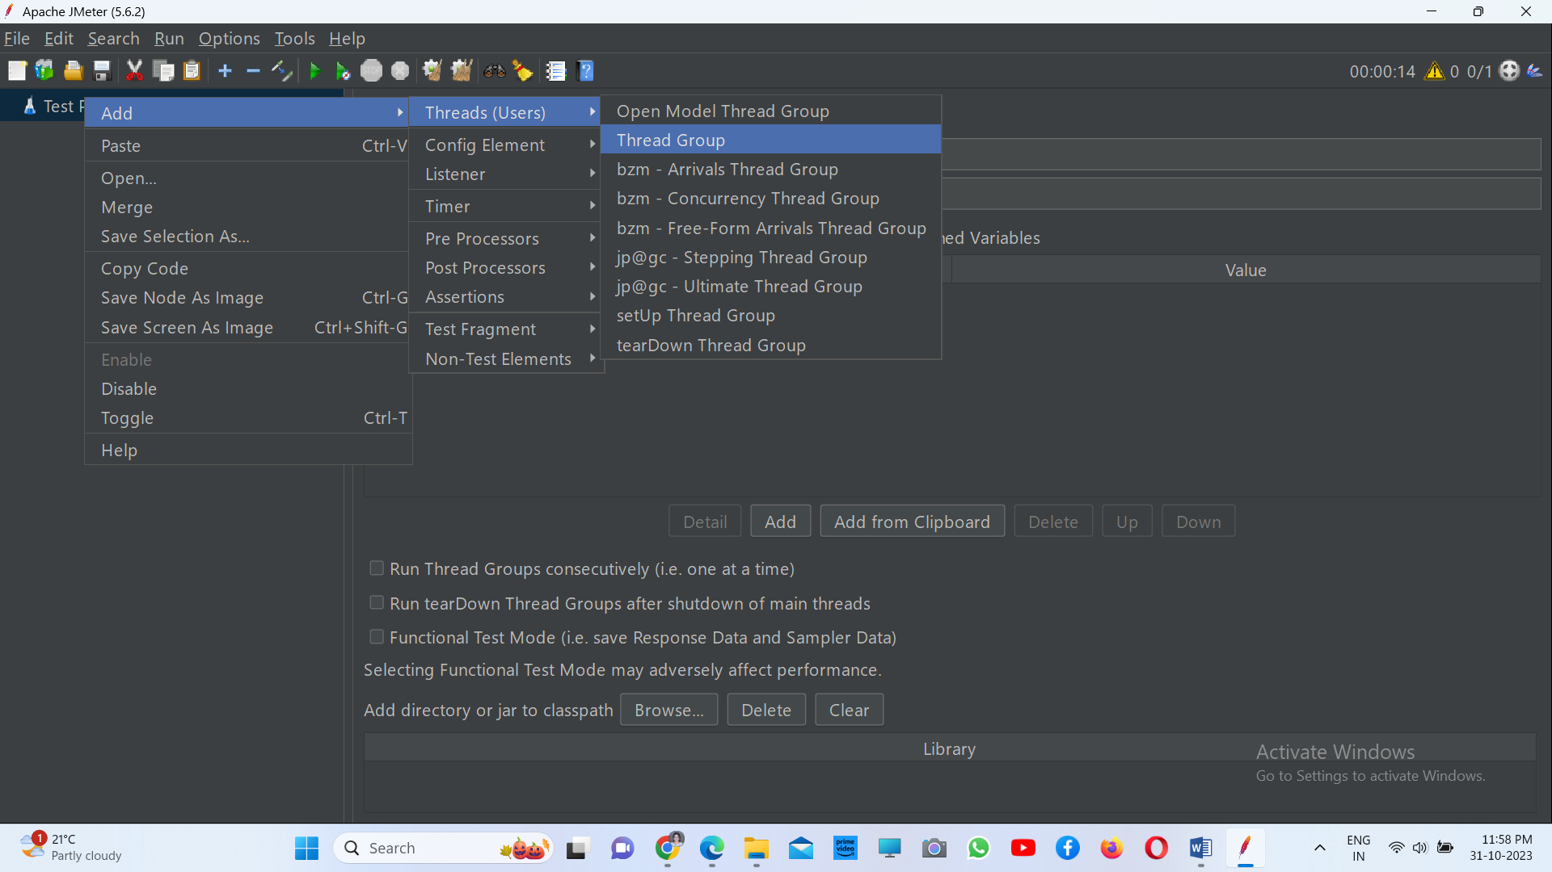

1. **Record the scripts**

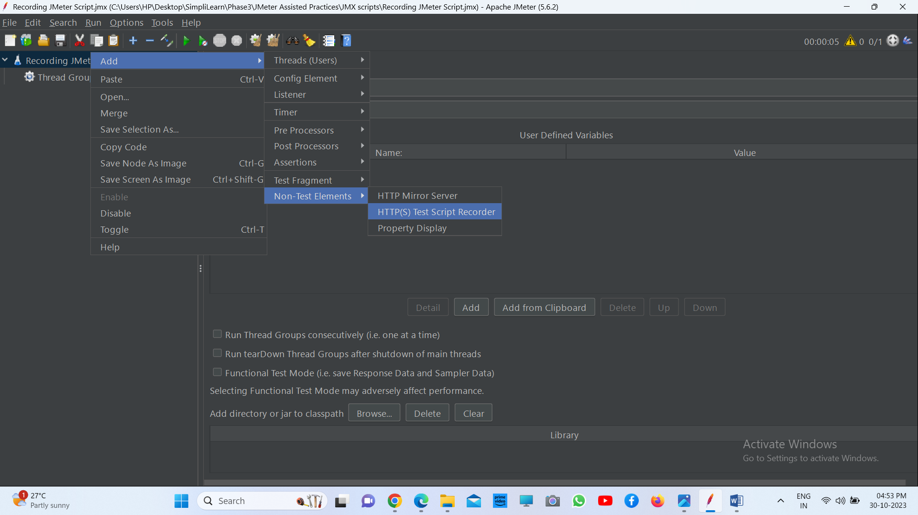

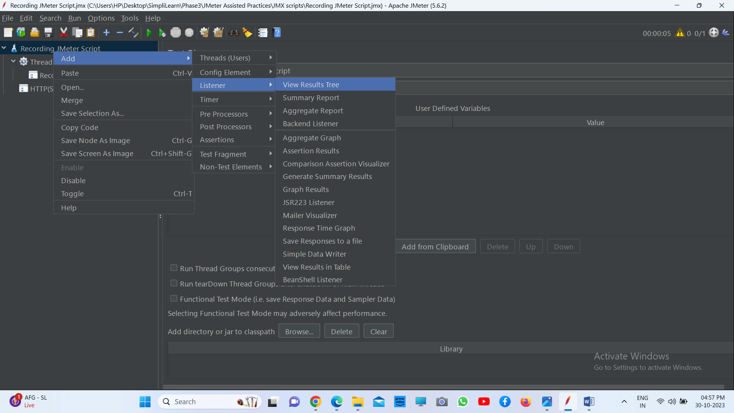

**Doing proxy settings**

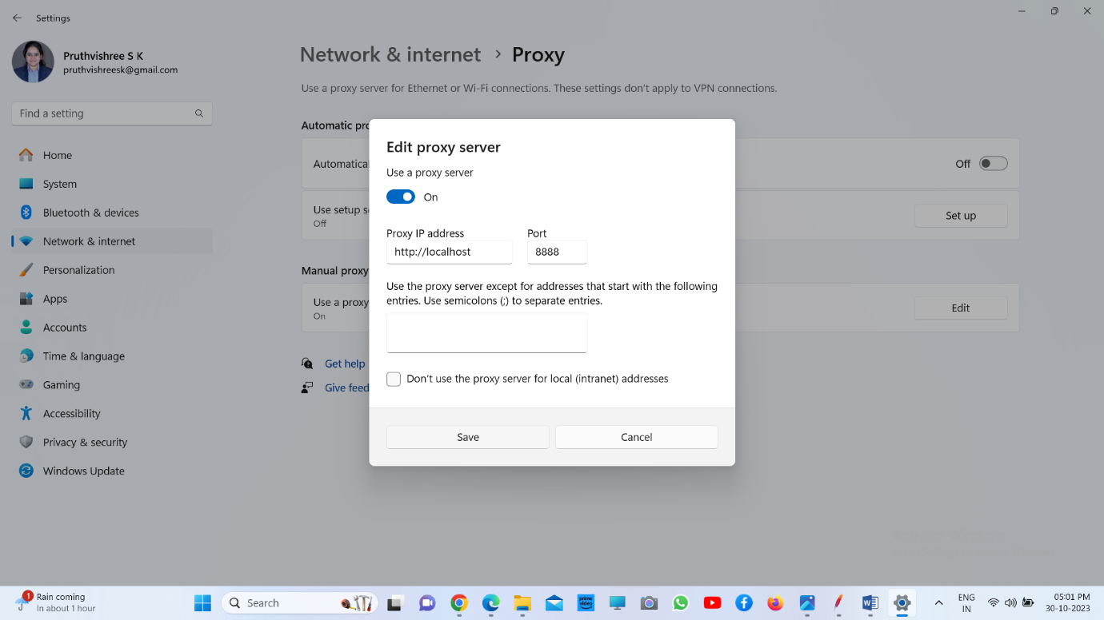

**Recording the script**

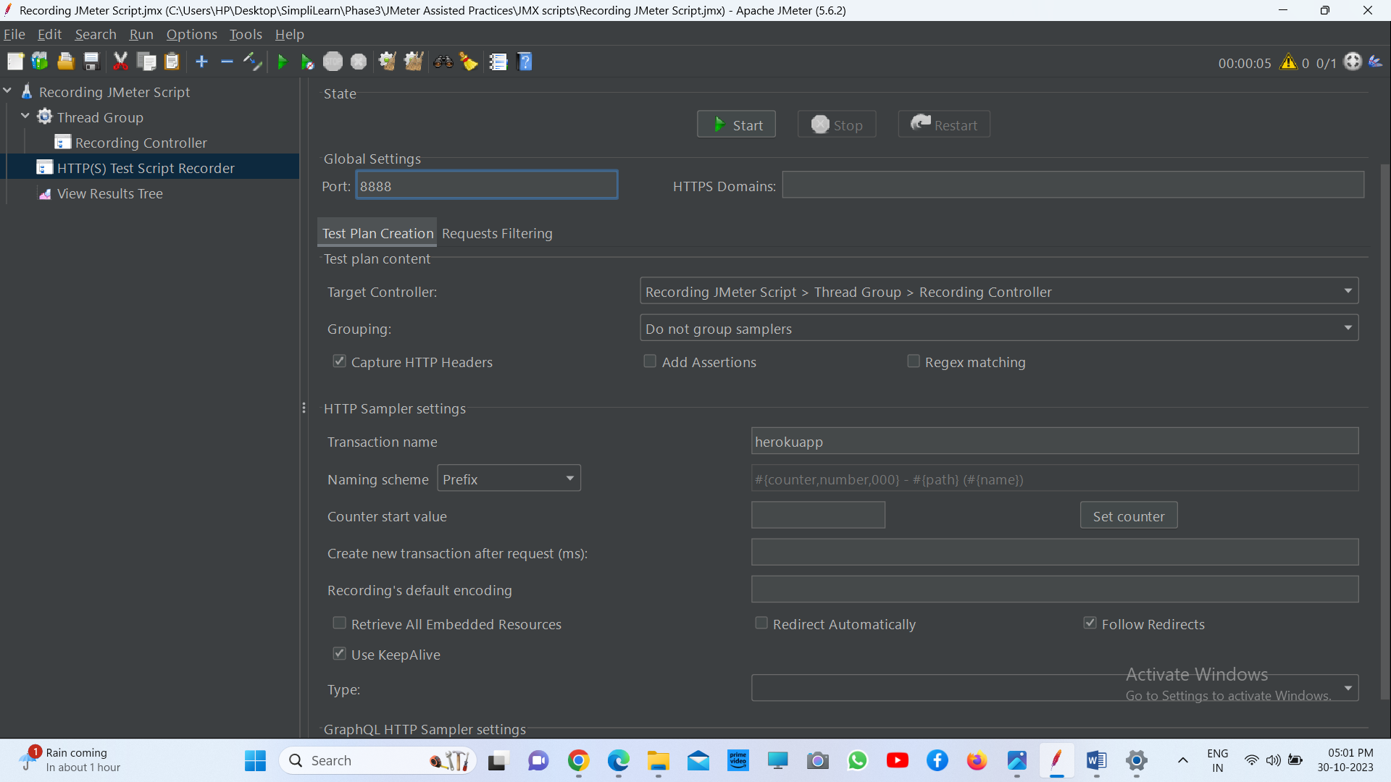

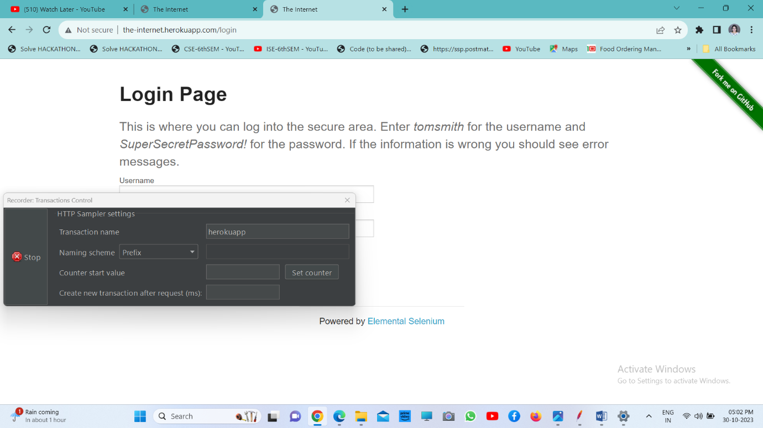

1. **Install WebDriver plugin.**

* Go to any browser and type JMeter plugins manager.
* Click on the link https://jmeter-plugins.org.
* Now, once you click on **Install**, you will get a jar file that will install the plugins.

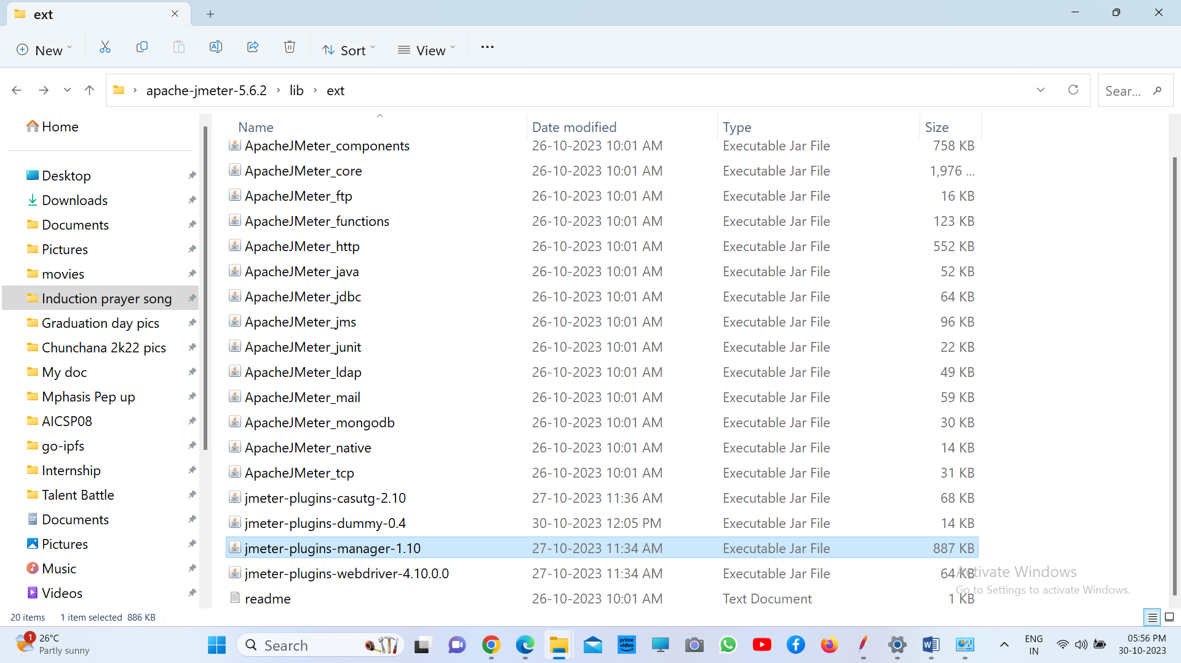

**Adding a specific thread group plugin**

* + Open the JMeter tool.
  + Click on the **Options** tab and then click on Plugins Manager.
  + Search for the custom thread group plugin and check the box next to it.
  + Finally, click on **Install** and restart the JMeter tool.

1. **Write Selenium scripts in WebDriver.**

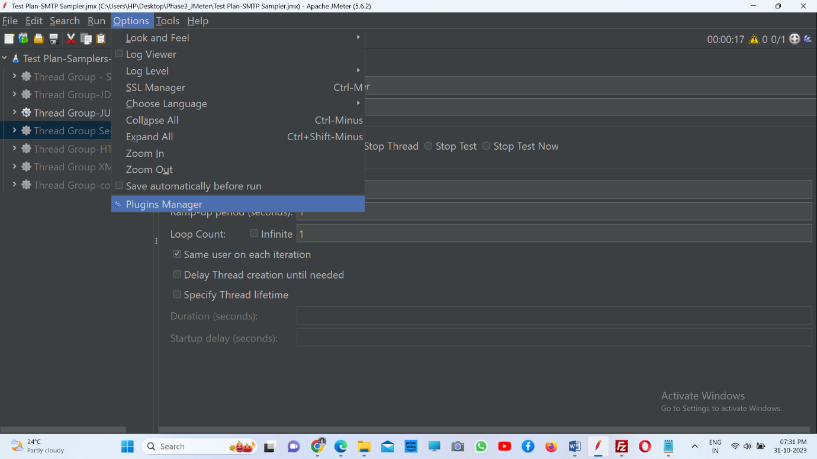

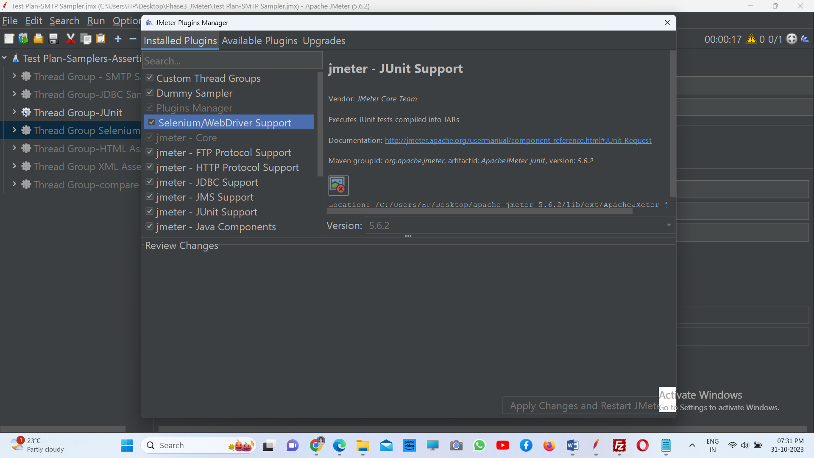

**Writing a WebDriver Script**

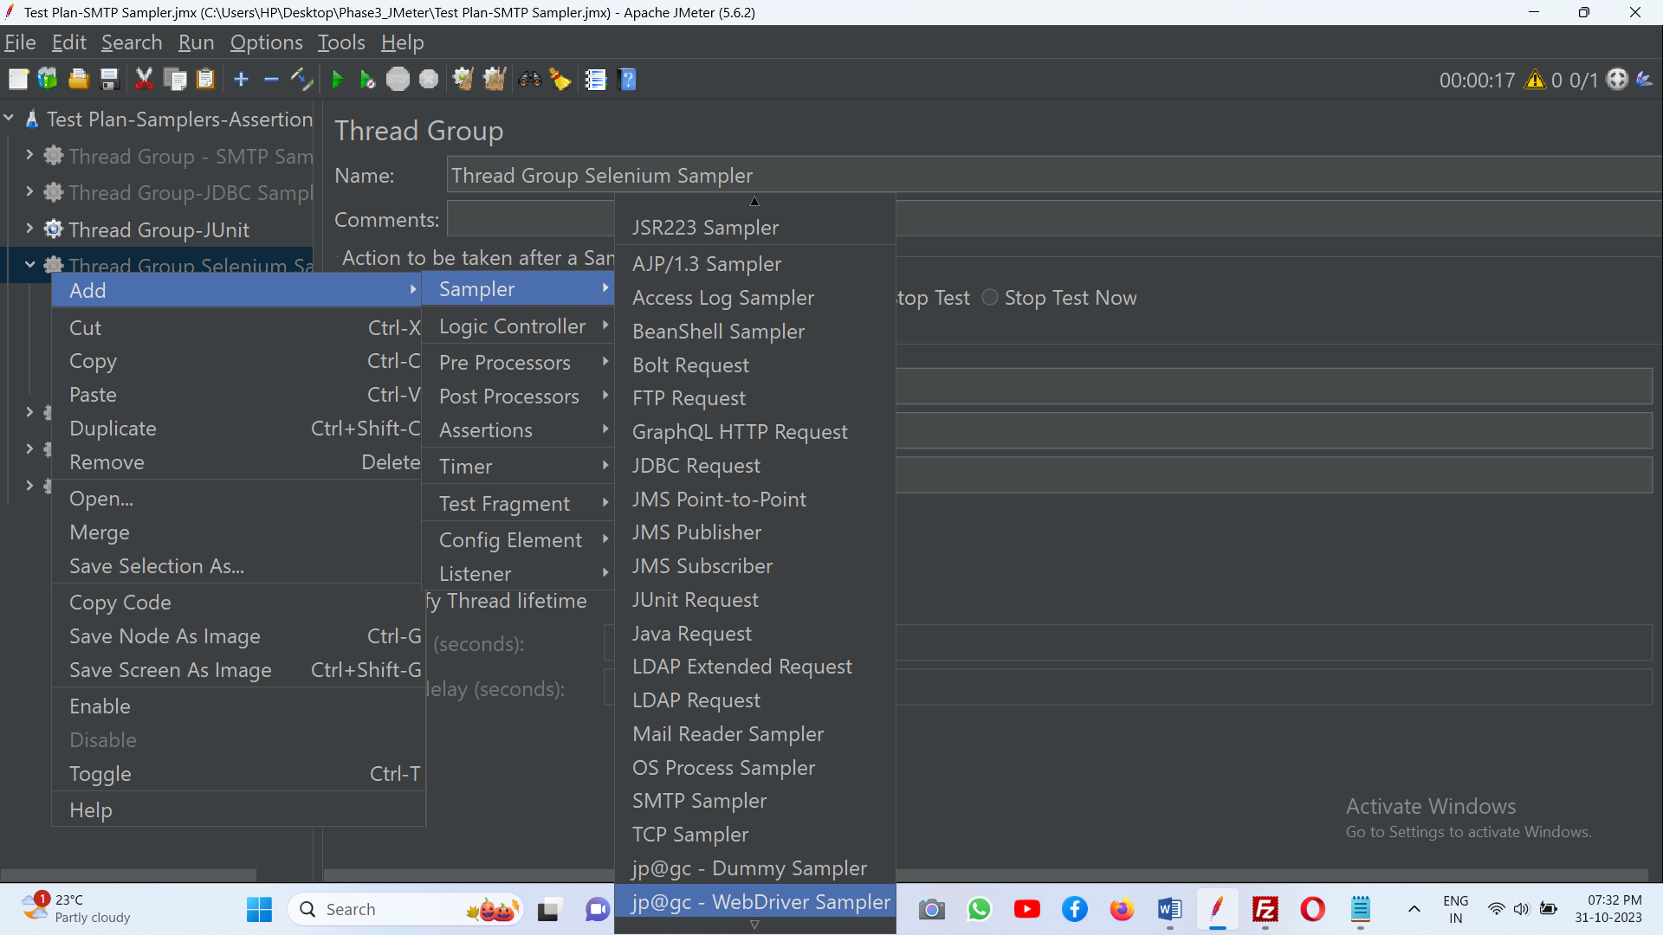

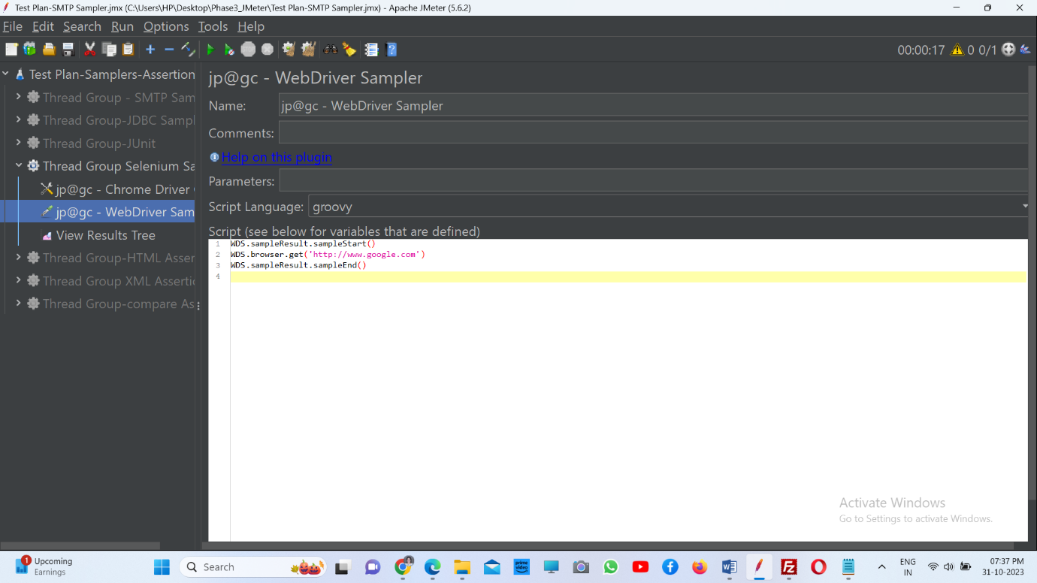

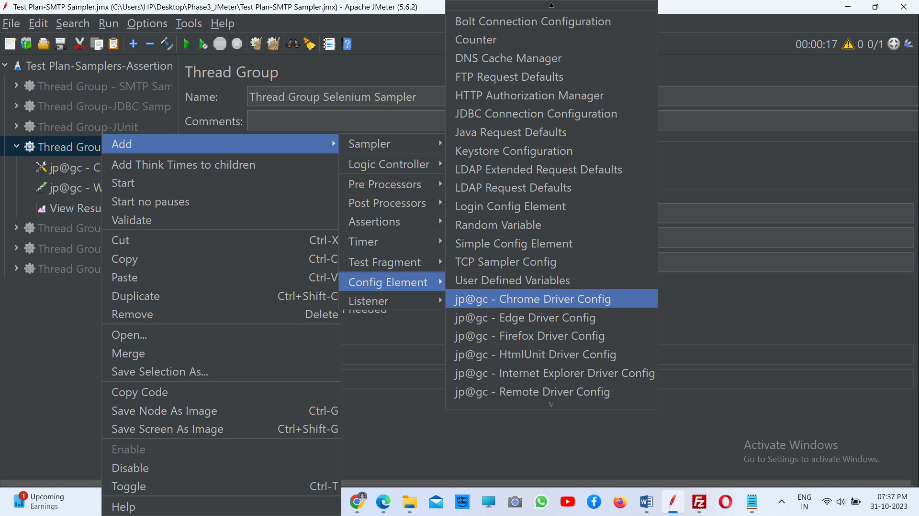

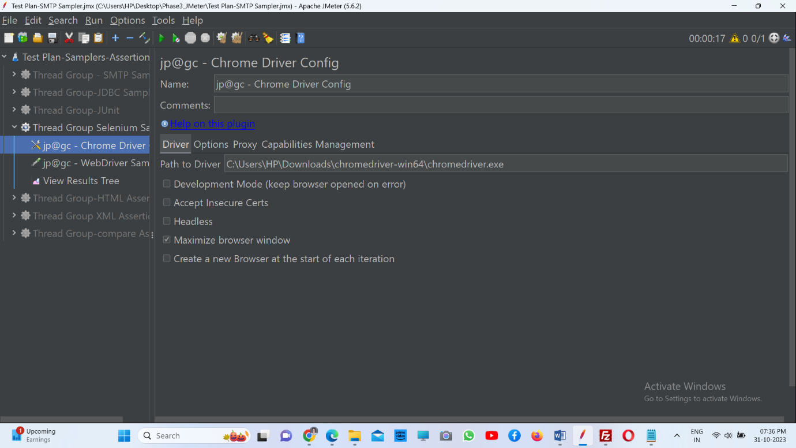

1. **Run the scripts and view the results**

